Study of shock wave boundary layer interaction using modal decomposition

Narendra Chaganti[1], Tyler Brooker2, Semih Olcmen3

University of Alabama, Tuscaloosa, Alabama, 35401

Pankaj Kolhe4

Indian Institute of Technology, Sangareddy, Telangana 502285, India

**Snapshot Proper Orthogonal Decomposition (SPOD) and Dynamic Mode Decomposition (DMD) have been used to study the flow features of oblique Shockwave Boundary Layer Interaction (SWBLI). Rainbow Schlieren Deflectometry (RSD) has been used to capture the flow data at 30,000 frames per second. The experimental setup produces a free stream flow of Mach 3.1. A 12° isosceles triangular prism attached to the roof of the test section generates the required oblique shock in the test section. The RSD pictures were used for data analysis to determine the transverse ray deflections at each pixel of the pictures. The analysis focuses on obtaining dominant flow regions in the flow and the corresponding modes at which they occur. This modal information is used to comment on the unsteadiness associated with the flow.**

# Nomenclature

*d =* transverse ray displacement

$\overline{d_{i,j}}$ = ensemble average deflection at each pixel

*ɛ =*  deflection angle

*fc* = focal length of lens

*k* = Gladstone Dale constant

*L* = width of test section

*n* = refractive index of air in test section

*no*= refractive index of air

*Nt*= number of pictures

*ρ* = density of air

$σ_{i,j}$ = standard deviation

$M_{1}^{N}$ = snapshot data represented in the form of matrix

*A =* linear operator

*S* = companion matrix

*U =* proper orthogonal modes of the data sequence $M_{1}^{N-1}$

$Φ_{i}$ = dynamic modes

*SVD* = single value decomposition

*SPOD =*  snapshot proper orthogonal decomposition

*DMD =* dynamic mode decomposition

*SWBLI* = oblique shock wave boundary layer interaction

# Introduction

T

he study of flow structure that is caused by the interaction between an impinging shock and a turbulent boundary layer has significant place in the high speed aerodynamics. The adverse pressure gradient imposed on the turbulent boundary layer due to increase in pressure across the shock wave affects the low momentum flow near the wall and makes the boundary layer prone to separation. In the case of separation, the separating boundary layer reattaches downstream once the pressure gradients are relaxed, which forms a separation bubble. The interaction of the impinging shock wave and the reflected wave with the boundary layer generates a complex flow field throughout the interaction. Low frequency motions of reflected shock, formation and motion of separation bubble, vortex shedding are some of the aspects that are widely studied. It is still an ongoing research to inter-relate each aspect of the above-mentioned studies. Recent references show that utilization of algorithms that extract the flow structures and complex behavior spatially and temporally has gained utmost importance. Consequently, if coherent structures are to be identified from experimental data, algorithms need to be designed that rely on these measurements.

A common technique for identifying coherent structures is the Proper Orthogonal Decomposition (POD) method. POD method determines the most energetic structures by diagonalizing the spatial correlation matrix computed from the snapshots. The flow structures can be extracted by the POD modes and the number of modes describing the flow depends on the type of flow that is being studied. Two major drawbacks that can be attributed to POD method are: (i) the energy may not in all circumstances be the correct measure to rank the flow structures, and (ii) loss of phase information. The first shortcoming has been widely recognized. The temporal and spatial structures, referred to as ‘chronos’ and ‘topos’, can be obtained by choosing a temporal or spatial average when computing the correlation tensor, or by using the classical POD (Lumley 1970) or snapshot POD (Sirovich 1987), respectively. The temporal structures (chronos) represent the eigenvectors of the spatially averaged temporal correlation matrix, while the spatial structures (topos) constitute the eigenvectors of the temporally averaged spatial correlation matrix. In either case, the averaging process may cause loss of information that might be important when classifying the dynamic processes contained in the snapshots. Dynamic Mode Decomposition (DMD) method is based on snapshots of the flow (Schmid & Sesterhenn 2008), that will still yield fluid structures that accurately describe the motion of the flow. In DMD, the extracted flow structures are termed as ‘dynamic modes’. This paper focuses on using both Snapshot Proper Orthogonal Decomposition and Dynamic Mode Decomposition to study the flow structures of SWBLI. Following section gives details about the experimental setup that has been used for the purpose of obtaining the RSD images.

# Experimental setup

**Figure 1.** shows the wind tunnel assembly setup. A storage tank of 12.7 mm thick wall and a volume of 28m3, with a maximum allowable design pressure of 1.38 MPa was used for the air supply purpose. Two, Ingersoll – Rand compressors of model SSR – HXP50SE with a capacity of 170 CFM were used to supply the compressed air to the storage tank. The compressors rated operating pressure is 1.275 MPa. A 3 phase, 60 Hz, 50 HP motor was used to run each of the compressors. For the purpose of drying the air, an automatic air-cooled Ingersoll – Rand dryer, model TZ300HP-EMS-3V-LDP was used. The desiccant used in the dryers was activated alumina with dew point of -73° C (-100°F). During the experiments, storage tank was charged up to 0.965 MPa.

Wind tunnel’s operating pressure was regulated by a 76.2 mm LESLIE pressure regulator. During the operation of the tunnel the pressure used in the pressure regulator was 0.448 MPa. The stagnation chamber contained a flow straightener, damping screen and a pitot probe. The flow straightener was made up of 101.6 mm long 12.7 mm in diameter steel tubes. In the experiments, an aluminum nozzle manufactured in house was used to obtain a Mach=3.1 flow in the test section. The nozzle was of 25.4 cm in length with throat area of 1.65 x 7.62 cm2.

The test section dimensions were 7.62 x 7.62 x 30.5 cm3. The side walls of the test section contained 2.54 cm thick, 7.62 cm diameter optical glass to have optical access into the flow to visualize both the boundary layer and SWBLI flow field. The test section floor was made up of solid aluminum. An isosceles triangle prism with 12° side angles was bolted to the ceiling of the test section to generate the desired oblique shock. Dimensions of the wedge used were 11.95 x 7.62 cm2 and 1.27cm thick at the center. The wedge is placed at a location such that the interaction region can be visualized through the glass side wall.

A variable area supersonic diffuser downstream of the test section was used to recover pressure to reduce the total pressure required to run the tunnel. A 63.5 cm long diffuser with an inlet area of the diffuser 7.62 cm x 7.62 cm and the outlet area 12.7 cm x 7.62 cm was used. The walls of the diffuser included a hinged plate, which could be adjusted to work with the different Mach numbers in the test section.

The wind tunnel was run without the wedge on the top ceiling, to get the boundary layer information. A pitot tube with a hypodermic needle was setup on a vertical traversing mechanism. This traversing mechanism enables the Pitot tube to traverse upwards and downwards in the test section. Using the traversing mechanism, the Pitot tube was then traversed vertically up from the surface of the test section floor to determine the pressure variations in the boundary layer. This pressure data was used to identify the corresponding boundary layer thickness. Mach number of the flow was determined based on the measured total pressure and the plenum chamber pressure. The flow temperature was T0 = 290 K. Based on this pressure data, the boundary layer thickness was calculated to be δ ≈ 7 mm. The free stream velocity for the experiments was obtained to be U = 620 m/s. For the current experiment the unit length Reynolds number was found to be 4.6 x 107 m-1.

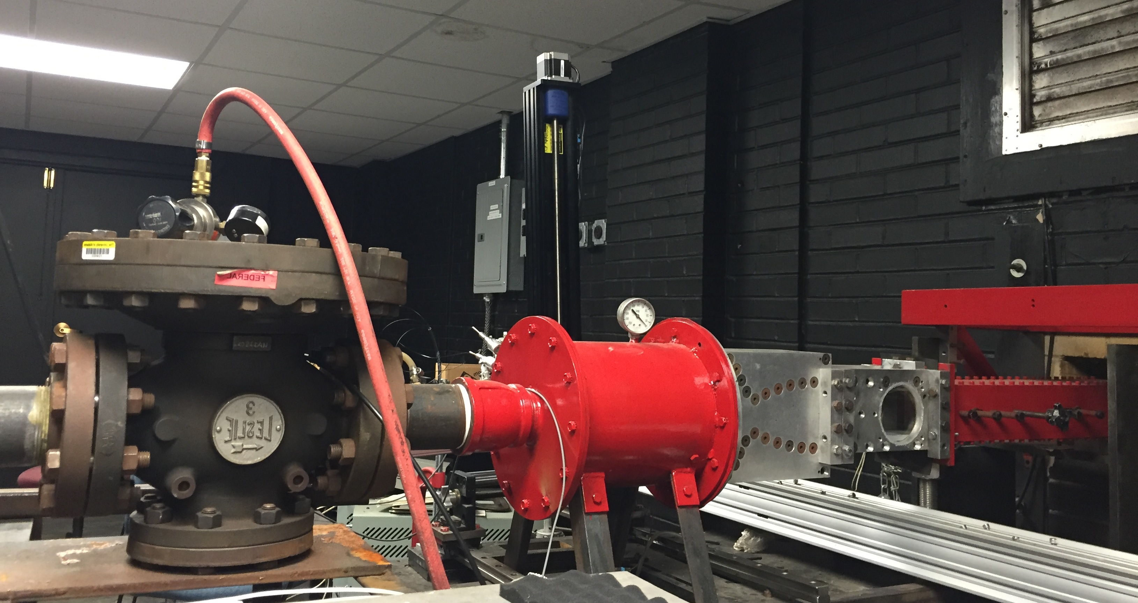

**Figure 1. A picture of the 3” x 3” cross section supersonic wind tunnel assembly.**

**2.2 RSD Apparatus**

The shockwave boundary layer interaction occurring in the test section was captured using the RSD apparatus. **Figure 2** shows the schematic of the apparatus. The light source in the experiment was 70 watt Cree XHP70 LED. A cooling mechanism was built for the purpose of cooling the light source. A 200-µm-wide aperture was placed in front of the fiber optic light source, through which light diverges.

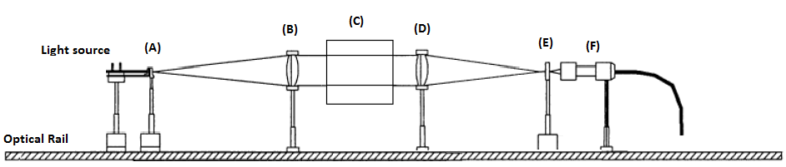 **Figure 2 Schematic sketch of Rainbow Color Schlieren apparatus, where (A) is source aperture, (B) is collimating lens, (C) is test section (D) is decollimating lens, (E) is rainbow filter, (F) is high speed camera.**

The light was collimated by an achromatic lens of 76.2mm diameter, 850 mm focal length and decollimated by 76.2 mm diameter, 850 mm focal length achromatic lens. The RSD filter was a 35 mm slide with 6.5 mm wide strip of continuously varying colors, which can be seen in **Figure 3.** The filter is continuously graded and hence transmits the light of particular wavelength corresponding to the location on the filter. This helps in calculation of the lateral displacement of light rays at the filter plane corresponding to each pixel location in the color schlieren image. The camera used for high speed imaging was Photron’s FASTCAM SA5.

**Figure 3. Asymmetric color filter.**

The color schlieren images were acquired at a rate of 30,000 frames per second by the camera, at exposure duration of 25µs. Digitized images were obtained at 448 x 376-pixel resolution respectively and were stored in a computer in TIFF format. Images were next cropped to 429 x 158 pixels respectively to analyze only the flow field seen through the circular side window of the tunnel. A total of 50,969 images were captured during the experiment.

# Techniques

**3.1 RSD Technique**

Schlieren methods have been used for the visualization of the flow fields associated with the shock wave boundary layer interaction (Kleine, and Groenig; Sugiyama). Density variations that occur during the shock wave boundary layer interaction can be clearly identified using the schlieren methods. To recognize the flow patterns of highly turbulent flows RSD technique preferred compared to black and white schlieren. RSD allows determination of the density gradients quantitatively and accurately, using a color filter and a calibration curve. In the RSD technique, the direct correspondence between the hue and the index-of-refraction obtained in the same flow field is used to determine the density gradients in the flow (Albers and Agrawal; Kolhe and Agrawal). In a flow field, the index-of-refraction changes due to the temperature variation in the flow, and the density of the flow field varies accompanying the temperature variation and the species concentration. In general, the densities across the test section changes during the run time.

In the RSD technique a white light beam passing through a slit is collimated by a collimating lens and let pass through the test section first. The light is next collected by a focusing lens and focused on to the color filter to form the image of the slit on the color filter. The camera is placed such that it accepts the light beam passing through the filter, while it is focused to the middle of the test section. In the case when there is no flow in the test section the light collected by the camera is seen as about a single color since the image of the slit is formed only at a narrow portion of the filter. Once the flow is on, the collimated beams passing through the flow deflect due to the density gradients in the flow, the image of the slit becomes wider and the camera sees different colors. The deflections that are a function of the density gradients can be determined using a calibration curve. Once the deflections are known, one can then determine the density gradients in the flow based on the images obtained by the camera. For the present application the flow is considered as a 2D flow, which provides a linear relation between deflection angle and density gradients.

During the experiments, the calibration curve was obtained by traversing the rainbow color filter from edge to edge in increments of 50µm and capturing images at each location without the flow in the test section. Once the slit image is focused close to the center of the filter, the image obtained is called as the background image, and the traverse position is considered as the zero displacement. The traverse distance difference vs. the hue then gives the calibration curve. In the current experiments, the Hue Saturation Intensity (HSI) color model rather than the RGB color model was used for the filter, such that the colors could be characterized by using just the hue value. The calibration curve can be seen in the **Figure 4**;the range of hue used is in between 33.02° to 262.4° instead of 0° – 360°. The hue values presented have a standard deviation of about 4.3° due to the presence of other colors within each calibration image. This corresponds to a distance uncertainty of ± 77μm.

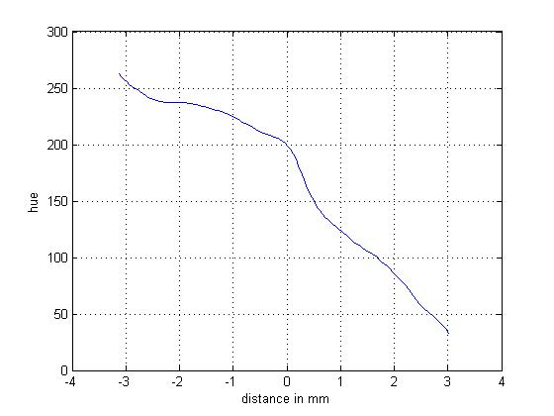

**Figure 4. Calibration curve.**

During the experiments, prior to the run, the filter was placed such that the image of the slit would focus on the filter at a desired location on the filter, such as at the center of the filter. A background image was obtained by the camera without the flow in the test section to determine the background hue and thus the origin for displacement measurements. The background hue was calculated as the average hue of the background image. The calibration curve was then used to determine the displacements from the background hue location. Once the background image is obtained, the location of the color filter should not be altered since this would immediately give erroneous results to the deflections that are reduced during the data reduction stage.

The relation between the density gradients and the deflections can be summarized as follows. The transverse ray displacement at the filter plane is given by:

$d=f_{c}ε$ (3.1.1)

where *fc* is the focal length of the decollimating lens, *d* is the deflection determined by the hue of the image at a pixel location and, *ɛ* is the deflection angle. The angular deflection of a light beam for a two-dimensional flow is given by:

$ε=(L/n_{0})\frac{∂n}{∂x}|_{Q}$ (3.1.2)

where *L* is the width of the test section, *no* is refractive index of air, n is refractive index of air in the test section at a point *Q*, *x* is the coordinate axis perpendicular to the optical path. For air, the relationship between the refractive index and gas density is given by:

$n-1=k . ρ$ (3.1.3)

where *k* is Gladstone-Dale constant, which is *k* = 0.23 cm3/g for air and *ρ* is density of the air. Hence using the refractive index and density relations, one can obtain:

$\frac{∂ρ}{∂x}|_{Q}=\frac{d . (1 + k . ρ_{0})}{L . k .{ f}_{c}}≈\frac{d}{L . k .{ f}_{c}}$ (3.1.4)

where *n0* is taken 1, since for air, refractive index is 1.

In the RSD technique similar to the black and white schlieren technique, the deflections perpendicular to the filter (or the knife edge for B&W schlieren) are captured. During the experiments, the slit and the color filter were placed horizontally such that they were parallel to the ground. This was done to capture the deflections of light in the direction perpendicular to the tunnel floor since the deflections were more pronounced in this position.

The images were analyzed with a MATLAB program written for this purpose. The program compares the calibration curve and the background image’s hue value and determines the zero shift position, reads the test images in Red-Green-Blue (RGB) color format and converts them to Hue-Saturation-Intensity (HSI) color format. The deflections are calculated using the zero shift value and the hue values of the images. In the current work, the deflection values were directly used to analyze the flow rather than the density gradients or the densities.

**3.2 Ensemble Averaging Analysis**

The transverse ray displacements obtained at every pixel of each of the pictures were then used to calculate the ensemble average and the standard deviation of the displacement values at every pixel location using all the subsequent pictures in a set taken during the experiments as:

$\overline{d_{i,j}}=\frac{\sum_{n=1}^{N_{t}}{d_{i,j}}}{N_{t}}$ (3.2.1)

where $\overline{d_{i,j}}$ denotes the ensemble average deflection at the pixel location given with the (i, j) indices, and the $N_{t}$ is the number of successive pictures used in the calculation. Each image is made up of 429 x 158 pixels, thus i index varied as i=1,.., 429, and j index varied as, j=1,.., 158. During the reduction the $\overline{d_{i,j}}$ corresponding all the images was calculated.

The standard deviation of the displacement at each pixel location was calculated using:

$σ_{i,j}=\sqrt{\frac{1}{{(N}_{t}-1)}\left(\sum_{n=1}^{N_{t}}{{\left(d_{i,j}-\overline{d_{i,j}}\right)}^{2}}\right)}$ (3.2.2)

An average of $σ_{i,j}$ was calculated next and reported.

**3.3 Snapshot Proper Orthogonal Decomposition**

Snapshot Proper Orthogonal Decomposition is one of the major statistical techniques utilized in the identification of the dominant structures in a flow field. Essential features of the flow field i.e., the energetic motions can be identified by the combination of the desired orders of the POD modes (Yang et al., 2009). For the purpose of turbulent flow characterization POD has been employed with either numerical or experimental data (Hilberg et al, 1994). Identification of large scale coherent structures in turbulent flows has been studied by Gurka et al. (2006).

Snapshot POD has been applied in identifying the dominant flow structures and flow dynamics in chemical process by Tabib and Joshi (2008). Using PIV velocity and unsteady wall pressure measurements in a Mach 2.3 flow and an oblique shock generator with a deflection angle of 9.5°, Piponniau et al. (2011) have identified the space-time correlation between wall pressure and velocity in a shock wave turbulent boundary layer interaction. POD and Linear Stochastic Estimation (LSE) were used in their analysis. Results were used to aid in predicting the unsteady aspect of the recirculating bubble.

SPOD, as mentioned, decomposes the flow fields into a series of POD modes with corresponding coefficients based on the orthogonal eigenfunctions. These eigenfunctions are used to identify the coherent structures from the flow fields. The pictures of the transverse ray displacement obtained using the RSD technique was also used as the input data for the snapshot POD analysis. In the POD analysis 4096 subsequent images were processed due to the computer memory limitations. Each picture with its 429 x 158 pixels formed the 2-D field at time $t_{n}$, and is referred as a snapshot. The total number of snapshots is denoted with $N_{t}$. Each snapshot had $n_{1}* n_{2}$ (429 x 158) data points. A time correlation tensor is obtained using these pictures and is given with the following equation:

${\left[R\right]}_{ij}= \frac{1}{n_{1}n_{2}}\sum_{l=1}^{n_{1}}{*}\sum_{m=1}^{n_{2}}{H\left(X_{lm},t_{i}\right)H(X_{lm},t_{j})}$ (3.3.1)

where $n_{1}$ and $n_{2}$ indicate the number of grid points in the x and y coordinate axes, respectively. In this equation, *H* denotes the deflection matrix. *X* denotes the coordinate variables. Using Fredholm equation POD coefficients are found with relation to the correlation matrix.

$RA^{(n)}=λ^{n}A^{n}$ (3.3.2)

$A^{n}=|a^{n}{\left(t_{1}\right),a}^{n}(t_{2}),…,a^{n}(t_{Nt})|$ (3.3.3)

where $A^{(n)}$ is the eigenvector matrix built up from the POD coefficients $a^{(n)}$, $λ^{(n)}$ denotes the nth eigenvalue and corresponds to the energy contained within the nth eigenmode. The amount of total energy associated with the flow field could be represented by the sum of *λ*(n)

(3.3.4)

where *N* is the number of eigenmodes. The POD mode is then obtained by projecting the original flow fields onto their corresponding coefficient as follows:

$Φ^{\left(n\right)}\left(X\right)=\sum_{k=1}^{N_{t}}{a^{\left(n\right)}\left(t_{k}\right)H\left(X,t_{k}\right)}$ (3.3.5)

All the POD modes are orthogonal and hence the reconstruction of any member of flow field can be calculated using:

$H\left(X,t_{k}\right)=\sum_{n=1}^{N}{a^{\left(n\right)}(t_{k})Φ^{\left(n\right)}(X)}$ (3.3.6)

If all the eigenmodes are used, the reconstruction allows one to obtain the original 4096 pictures. Using a single mode or chosen multiple modes in the reconstruction allows one to obtain 4096 sequential pictures corresponding to that single mode, or to the chosen multiple modes. One can obtain the sequential pictures corresponding to certain eigenmodes by truncating the full series of eigenmodes to a desired order

$\hat{H}\left(X,t_{k}\right)=\sum_{n=1}^{K}{a^{\left(n\right)}(t_{k})}Φ^{\left(n\right)}(X)$ (3.3.7)

where K denotes the desired number of eigenmodes used in the calculation. In this equation the n=1 was used indicating the energy mode which when reconstructed resembles the average flow field. However, the starting value for n may be set as any value desired. Among all the modes, the most energetic mode represents the dominant pattern of the flow field. In the calculations eigenvalues are used in a descending order, such that 𝜆𝑛>𝜆𝑛+1.

**3.4 Dynamic Mode Decomposition:**

The process of the dynamic mode decomposition (DMD) follow arguments used in iterative methods for computing solutions to linear eigenvalue problems or other linear algebra problems (Schmid 2010). This method is equally applicable to experimental as well as numerical flow field data.

The procedure starts with re-arranging the data such that the snapshots are arranged in the form of $a x b$ format, instead of $a x b x c$. Here, $a$ represents data corresponding to each pixel, and, $b$ represents the total number of snapshots considered for analysis. This step is required to eliminate inherent measurement noise in the data. Next, the data is represented in the form of a snapshot sequence, given by a matrix ${ M}_{1}^{N}$.

$M_{1}^{N}=\{m_{1},m_{2},m_{3,}…m_{N}$} (3.4.1)

where $m_{i}$ stands for the *i*th flow field. In the above definition, the subscript 1 denotes the first member of the sequence, while the superscript *N* denotes the last entry in the sequence, i.e. the first and last columns of the matrix $M_{1}^{N}$ respectively. It is further considered that the ordered sequence of data is separated by a constant sampling time *Δt*; which is the time step between two consecutive snapshots. The first step after re-arranging the data would be, to assume a linear mapping *A*thatconnects the flow field $m_{i}$ to the subsequent flow field $m_{i+1}$ that is,

$m_{i+1}=Am_{i}$ (3.4.2)

This mapping is the same over the full sampling interval [0*,* (*N* − 1) *Δt*]*.* The assumption of a constant mapping between the snapshots $m_{i}$ allows to formulate the sequence of flow fields as a Krylov sequence (Greenbaum (1997); Trefethen & Bau (1997)).

$M_{1}^{N}=\{m_{1},{Am}_{1},A^{2}m_{1},…A^{N-1}m_{1} \}$ (3.4.3)

Since from 3.4.2

$m_{3}=Am_{2}$. where $m_{2}=Am_{1}$; hence $m_{3}=A^{2}m_{1}$**;**

The goal of this process is to extract the dynamic characteristics (eigenvalues, eigenvectors, energy amplification etc.) of the dynamical process described by *A*based on the sequence ${ M}_{1}^{N}$*.*

As the number of snapshots increases and the data sequence given by $M_{1}^{N}$ captures the dominant features of the underlying physical process, it is reasonable to assume that, beyond a critical number of snapshots, the vectors given by (3.4.2) become linearly dependent. That is, adding further flow fields $m_{i}$ to the data sequence does not improve the vector space spanned by $M_{1}^{N}$*.* When this limit is reached, one can express the vector $m_{N}$ which is the last entry of the sequenceas a linear combination of the previous, and linearly independent, vectors $m_{i}$ for*, i* = 1*…, N* − 1 as follows

$m_{N}=a_{1}m_{1}+{a_{2}m}_{2}+{a_{3}m}_{3}… {a_{N-1}m}_{N-1}+r$ (3.4.4)

Or in matrix form as

$m_{N}=M_{1}^{N-1}a+r$ (3.4.5)

where $a^{T}=\{a_{1},a_{2},a_{3,}…a_{N-1}$} and r is the residual vector.

Using the concepts from Ruhe (1984), one can simplify the above equations as follows:

$A\{m_{1},m_{2},m_{3,}…m_{N-1}$} = $\{m_{2},m_{3},m_{4},…m_{N}$} = $\{m_{2},m_{3},m_{4},…M_{1}^{N-1}a$} + r $e_{N-1}^{T}$ (3.4.6)

Above equation can be written in matrix form as

$AM_{1}^{N-1}=M_{2}^{N}=M_{1}^{N-1}S+r e_{N-1}^{T}$ (3.4.7)

where ${e }_{N-1}$ ∈ $R^{N-1}$ as the (*N* − 1)th unit vector.

Hence from the equation 3.4.7 matrix **S** appears to contain the elements as follows:

 (3.4.8)

The sub-diagonal entries reflect the fact that, by design, the vector in the *i*th column of $M_{2}^{N}$ is identical to the vector in the (*i* + 1)th column of $M_{2}^{N-1}$ for *i* = 1*, . . . , N* − 2*.* The only unknowns in the matrix *S*are the coefficients {$a_{1},a_{2},a_{3,}…a_{N-1}$} which constitute the (*N* − 1)-component linear representation of the last sample $m_{N}$ in terms of the previous samples ${ m}_{1},m_{2},m_{3,}…m_{N}$*.* The eigenvalues of *S*  approximate the eigenvalues of *A.* A robust approach is used in simplification of *S***.** Similarity transformation is performed on this matrix. After this step another preprocessing step is used, which is ‘singular value decomposition’ of the data sequence ${ M}_{1}^{N-1}$, such that, $M_{1}^{N-1}=UƩW^{H}$. This is further substituted in equation 3.4.7. Upon re-arranging thus substituted equation one can obtain the equation for $\tilde{S}$ as follows:

$U^{H}AU=U^{H}M_{2}^{N}WƩ^{-1}=\tilde{S}$ (3.4.9)

The matrix U contains the proper orthogonal modes of the data sequence ${ M}_{1}^{N-1}$. The above operation amounts to the projection of linear operator *A* onto a POD basis. The modal structures can be extracted from the matrix $\tilde{S}$ in a manner analogous to recovering the global modes from eigen vectors. It is also a suggested at this point to sort the eigen values from higher to lower for the purpose of identifying the modes. The following expression can be utilized for obtaining particular dynamic modes ${ Φ}_{i}=Uy_{i}$, where $y_{i}$ is the ith eigen vector of $\tilde{ S}$. In the above equation U acts as the right singular vectors of the sequence $M_{1}^{N-1}$. This process of decomposition thus is able to extract the coherent structures from a sequence of data fields.

# Results

The transverse ray displacement values calculated in RSD were used to calculate the ensemble average and the standard deviation of the deflections at every pixel location. **Figure 5** shows the ensemble averaged deflection contour plot and the important flow features obtained. Numbers in the abscissa and ordinate denote the pixel numbers. A positive deflection indicates a density increase in the direction away from the wall, while a negative value indicates density decrease in the same direction. **Figure 5** clearly shows the approach turbulent boundary layer, the incident and reflected shocks, separation shock, separation bubble, lambda shock formation, expansion region, re-attachment compression waves. The deflections are higher through the shock waves and across the expansion region as there is considerable amount of density change across these regions. The deflections in the separation bubble were close to zero since the flow in this region is subsonic. Highest deflection values are observed in the region over the separation bubble downstream of the incident shock wave at the foot of the expansion region.

As discussed by Delery and Dussauge (2009), the pressure rise experienced by the flow passing over incident and reflected shock waves generates an adverse pressure gradient on the subsonic flow very near the wall and results in a reversed flow region. The reversed flow behaves as an obstacle and generates the separation shock. After the initial creation of the separation shock the pressure downstream of the separation shock dictates the pressure seen near the onset of the separation bubble. The interaction of the original incident shock and the separation shock occurs at a region away from the wall above the approach boundary layer thickness. Penetration of the incident shock wave into the viscous rotational flow region over the separation bubble results in further pressure increase downstream of this shock and effects the characteristics of the reflected shock as the flow between the reflected shock and the transmitted shock has to have a single static pressure and single flow direction considering the inviscid theory. The pressure rise downstream of the transmitted shock decreases by the expansion waves which also turns the flow towards the wall resulting in closing the separation bubble, while equalizing the pressure within the separation bubble and the region over the aft section of the bubble. Separation bubble region near the wall seems to extend beyond the view of the camera since density gradients are present near the wall beneath the compression wave zone. The ensemble averaged image tells that the positive deflections tend to occur in the incident shock, near the intermittent region where the separation shock interacts with the separation bubble. The majority of positive peak deflections occurred in the region of expansion region below the reflected shock. On the other hand, the peaks of negative deflections were mainly oriented along the reflected shock wave.

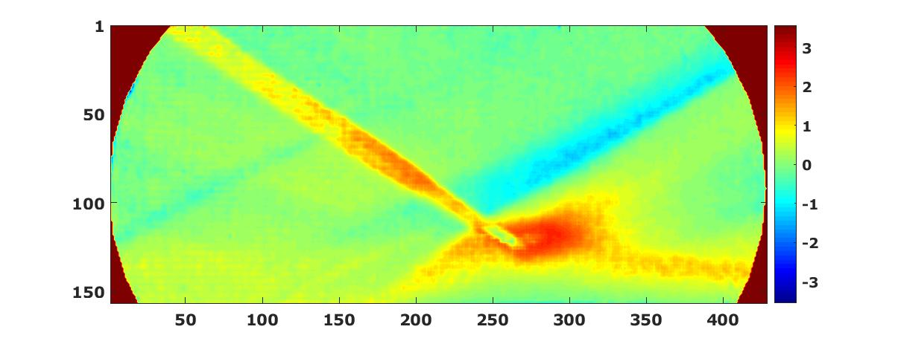

**Figure 5, Ensemble averaged deflections**

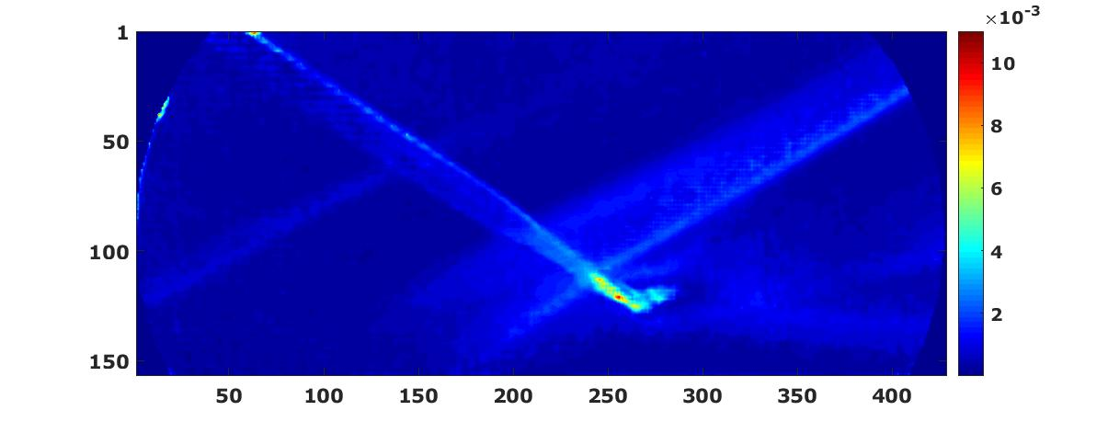

**Figure 6 RMS values of the deflections**

The RMS values as shown in **Figure 6** are higher along the edges of the incident and reattachment shocks, along the separation and reflected shocks, within the shear layer over the separation bubble and at the foot of the expansion waves in both cases. The values are highest at the region where the shocks intersect. The density gradients seen around the incident shock and reflected shock wave in both Figures 5 and 6 is believed to be due to the interaction of the shock wave with the boundary layer of the side walls of the tunnel.

**Snapshot POD results:**

Snapshot POD has been performed on 4096 successive images using the process mentioned in the techniques section. It is observed that the energy content corresponding to the eigen modes decayed fast and contained relatively small amount of total energy as the mode number increased. The energy contribution of modes till 23 can be seen in Figures 7. Only the fluctuating modes were used to in this Figure 7. Individual eigen modes starting from the highest eigen mode were used for the regeneration. The re-construction of the flow field is performed to observe the flow structures corresponding to these modes.

**Figure 7 Energy content with respect to modes**

The first nine modes were chosen for reconstruction. **Figure 8** is the re-constructed flow field pertaining to all the eigen modes apart from the highest energy mode. It can be seen that the majority of the energy is concentrated in the reflected shock and in the expansion fan. A considerable amount of energy content is also situated in the region of incident shock, foot of reflected shock and surrounding the separation bubble.

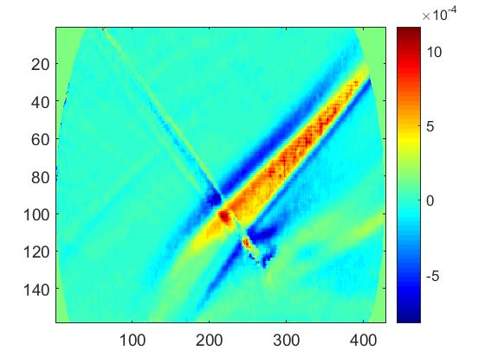

**Figure 8 Flow corresponding to rest of the energy modes apart from the highest energy**

**Figures 9 a-i** are the flow structures corresponding to the first highest energy mode to the ninth highest energy mode.



h

h

The ranges of the color bar changes from one insert Figure to the other since the deflection values vary substantially for different modes. All the higher order mode plots show that most of the energy is distributed along the shock waves, in the vicinity of the compression zone, over the separation bubble. The deflections in the flapping structure of the separation shock tend to peak in the figures b, c, f, h and i. The contributions to the reflected shock also become clearer at the higher order modes.

Figure 9-a shows that the energy of the flow field is more concentrated in the region of the separation and reflected shocks, and top portion of separation bubble. Figures 9-b and c show that major deflections are around the separation and the reflected shock waves, in the interaction region, close to the foot of the reflected shock and also near the expansion region downstream the recirculation zone. The negative deflections can be seen in the region of the reflected shock which are also high, but of negative order. Figures 9-d and e, display that the deflections are high in the region of shock-shock interaction. Figures 9 f, h and i, show that both positive and negative displacements are high in the incident, foot of the separation and reflected shock. These deflections can be associated with the unsteady shock motion as they are dominant in these particular energy modes. The variations in Figures 9 b and c are close to each other indicating positive and negative deflections around the separation and reflected shocks. Flow structures pertaining to other modes were not presented here as it has been observed from the eigen mode and corresponding energy content plot (Figure 7) that the energy content decreased significantly as mode number increased.

**DMD results:**

Dynamic Mode Decomposition (DMD) method is based on snapshots of the flow (Schmid & Sesterhenn 2008), that will still yield fluid structures that accurately describe the motion of the flow. In DMD, the extracted flow structures are termed as ‘dynamic modes’. Execution of DMD in current experiment had been performed on 30 KHz data. Hence the resolvable frequency of 15,000 Hz would be sufficient to identify low frequencies till high frequencies. A total of 50,969 images were used in this process such that the time interval between the two successive snapshots would be 3.333e-05 seconds. The images were cropped such that it would optimize the computing time for SVD and eigen values. The cropped images in the current experiment had dimensions of 333 x 157, hence n = 50,969 and m =52,281. Where n is total number of snapshots and m is total number of pixels. Once the matrices were formed as explained in the techniques section, SVD was performed on $M_{1}^{N-1}$ and subsequently $\tilde{S}$ matrix was found using the algorithm presented in techniques section. Eigen values were obtained for $\tilde{S}$ matrix and were used to obtain the Ritz plot and dynamic spectrum. The imaginary eigen values are used to obtain the dynamic spectrum which also convey the frequency content of the data. The real part of eigen values provide information about the stability of the associated mode. In the dynamic spectrum plot, if the real part of eigen value is greater than zero it is termed as unstable, near to zero is termed as stable and below zero represents modes that decay with time. Ritz plot was also used for the purpose of identifying stable and unstable modes by plotting imaginary part of eigen values against the real part of the eigenvalue. The plot would yield points that loosely follow the contours of a circle with unit radius. The points lying outside of this unit circle can be treated as being unstable (corresponding to the modes that increase exponentially with time). The points that lie inside the unit circle corresponds to modes that decay over time. The points that are very close to the unit circle or on the unit circle correspond to stable modes and would be used in the reconstruction of the flow field.

As mentioned earlier, from the eigen values of $\tilde{S}$ the real and imaginary parts can be separated. The frequency content can be obtained from the imaginary eigen values using the following relation. $λ_{j}=\ln\left(μ_{j}\right)/2πdt$, where $μ_{j}$ represent the eigen values. The real and imaginary parts of $λ_{j}$ were separated. Dynamic spectrum plot can be obtained when real and imaginary parts of the eigen values obtained using the above formula were plotted. The real part provides the information regarding the stability of a given mode. If the real value is greater than zero, that mode can be treated as unstable. Similarly, if the real value is below zero, that mode decays its energy with time, which also would not be taken into consideration for future study. The real values of $λ_{j}$ which are very close to zero are treated as stable modes which alone would be used in the reconstruction of the flow-field. The imaginary part of $λ_{j}$ gives the frequency details corresponding to a given mode. When the imaginary $λ_{j}$ and real $λ_{j}$ are plotted, the range on the x-axis varies with the negative Nyquist frequency to positive Nyquist frequency symmetrical about zero. In the current experiment the x-axis ranges in between -15,000 Hz to 15000 Hz for 30,000 Hz sampling frequency.

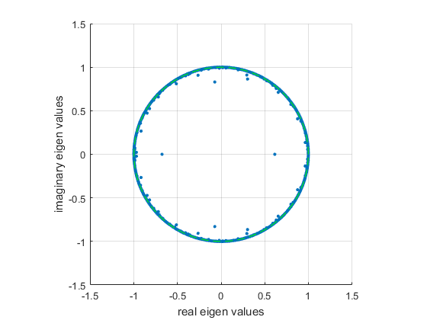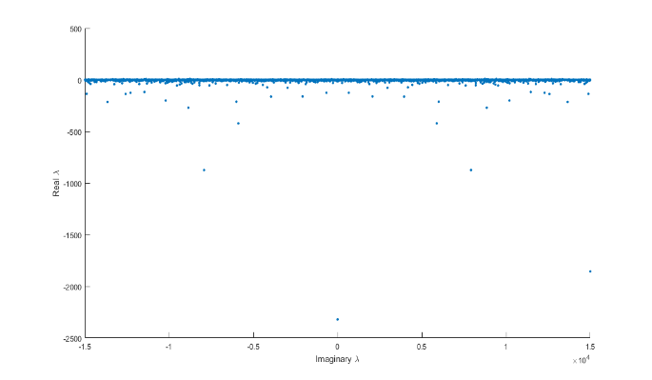

**Figure 10. Ritz plot Figure 11. Dynamic spectrum plot**

Figure 10 shows Ritz plot with 50969 samples, hence containing all 50,969 modes. This process will lead to tedious level of dominant mode separation. Hence, the stable modes, are picked again using MATLAB program using the algorithm presented above in the techniques section and a refined Ritz plot is plotted as below with reduced rank. Using the stable eigen values along with the global energy norm dominant modes were chosen based on the algorithm for reconstruction of the flow field.

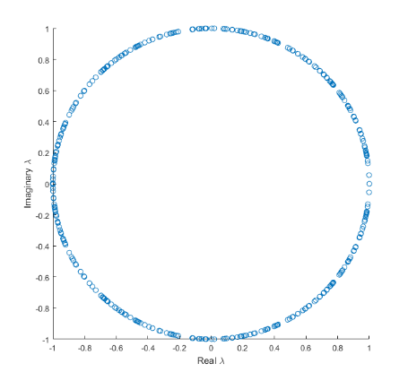

**Figure 12. Ritz plot with desired eigen values**

During the process of reconstruction only the positive side of the frequencies were considered from the symmetric plot. Once the frequencies are calculated, the modes $Φ_{i}$ are calculated. To obtain the modes which best represent the flow structure, it would be a necessary step to find the modal amplitudes or global energy norm. DMD modes are ranked based on their contributions to the total energy in the flow field by using this global energy norm of each mode which is also represented as $\left\|Φ_{i}\right\|$ (Zhang et al 2013, Rowley et al 2009, Mohd Y. Ali 2016). This global energy norm is then plotted against the frequency to capture the dominant modes. The dominant modes obtained in this process are then used for reconstruction of the flow field at their corresponding frequency. The following picture shows the plot in between the frequency versus global energy norm.

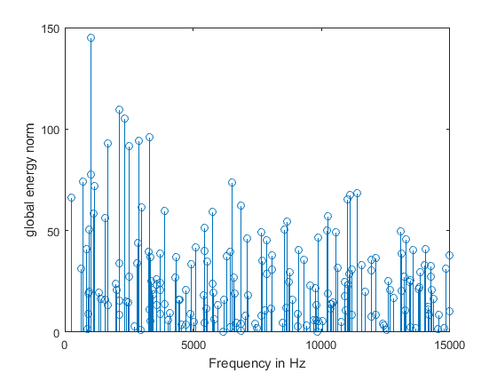

**Figure 13 Frequency vs global energy norm.**

Using the information from Figure 13, the flow field contours are reconstructed. Similar to snapshot POD where the mean flow can be obtained with the mode that is having the highest eigen value, DMD also provides that capability of generating mean flow mode. In DMD this mode corresponds to 0 Hz. Although the mean mode exists at 0 Hz, it was removed from the plot and removed from this discussion as well, since it was very well covered in the ensemble average results. Hence reconstructed flow field related to mean mode was not covered in detail both in snapshot POD and in DMD section. A more detailed explanation about each reconstructed flow field and its description corresponding to the regions of SWBLI is presented down below.

The reconstructed flow fields from Dynamic Mode Decomposition (DMD) have been organized into a canvas in Figure 14. As per the regions of interest in SWBLI, the low frequency section which corresponds to separation shock, and regions of expansion to reattachment are given importance to study the unsteadiness in the flow. DMD technique has proven to be a valuable method to determine specific frequency content in coherent structures which is a key distinguishing capability when compared to POD. As seen from the Figure 13, which corresponds to frequency vs global energy norm, the frequencies occur as a form of broadband rather than a specific peak at a given frequency location. A band of frequencies have been chosen for each region of interest, out of which the first band corresponds to low frequency content ranging from 450-1000 Hz. And mid - level frequency ranges from more than 2000 Hz to 9000 Hz. The range on the color bar in Figure 14, varies for each figure since the deflection values vary substantially for different modes.

As it can be seen from the images, at the low frequency range the dominant flow features are present in the shock regions and closer to the portion of expansion and reattachment region. The scaled images provides with the information that the density fluctuations appear to be positive in magnitude in the shock regions, compression region below the expansion fan. Whereas negative fluctuations were found in the region close to expansion and parts of incident shock.

The region near the expansion region which experienced high negative fluctuations, shows that there could be some parts of the flow corresponding to parts of expansion region which would experience low frequency motions. From the frequency and global energy norm plot in Figure 13, frequencies corresponding to 1100 Hz to 1400 Hz also showed some increment in global energy norm, but the flow structures showed faint density fluctuations in shock – shock interaction region as compared to the above figures, hence those figures were not included here. It can be observed that the deflections in the dominant flow shifts from the separation shock to the regions of the flow where flow exhibits higher frequencies. Although the flow structures show the incident and reflected shock regions, it can be clearly observed that the deflections in these regions of flow is much lower than at the flow structures exhibited in the lower frequencies.

Due the complexity of the flow and also due to the experimental constraints concrete visualization of vortex structures or vortex shedding could not be obtained here in the current experiment. However, an effort is made here with respect to DMD analysis as mode structures corresponding to higher frequencies could be obtained based on the algorithm. These relatively higher frequency motions come in to existence based on the complex flow that occurs below the interaction region. Major reason for the flow to exhibit higher frequencies compared to the low frequency separated shock motions can be attributed to the shedding of vortices inside the interaction zone. The convection phenomenon was reported in literature in this region of the flow. From the canvas, we can see the deflections or the flow contours gradually saturate as the frequencies increase towards higher values. Once the frequencies reach more than Strouhal number of 0.5 the flow becomes over saturated, that discerning dominant structures in the flow becomes difficult. It is worth noting that, the current experiment has been successful in identifying low frequency components than higher frequency components.

As explained in the experimental setup, the maximum resolvable frequency in using the 30,000 Hz data is 15,000 Hz, the frequencies that correspond to the desired flow structures fall well below this maximum limit of resolvable frequencies. It can also be deduced from this analysis that the reconstruction using dynamic modes also show similar characteristics as the flow structures obtained from Snapshot POD, where the energy of the modes decreased at a very high pace such that as the mode number increased the reconstructed flow corresponding to them showed saturated flow. However, POD failed to provide any frequency related information for corresponding modes. It can also be mentioned here that using DMD flow reconstruction, the lower frequency coherent structures were obtained with relatively discernable dominant flow structures when compared to higher frequency coherent structures.

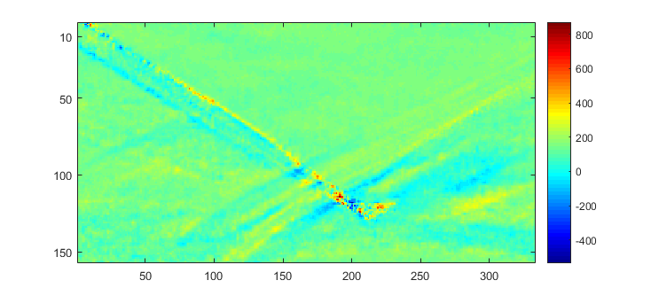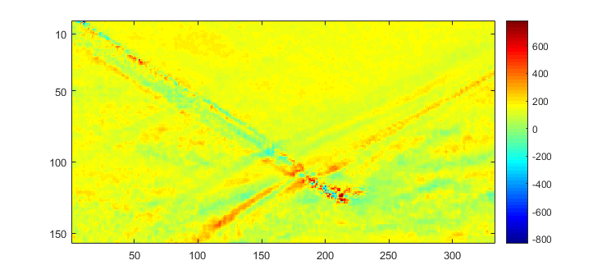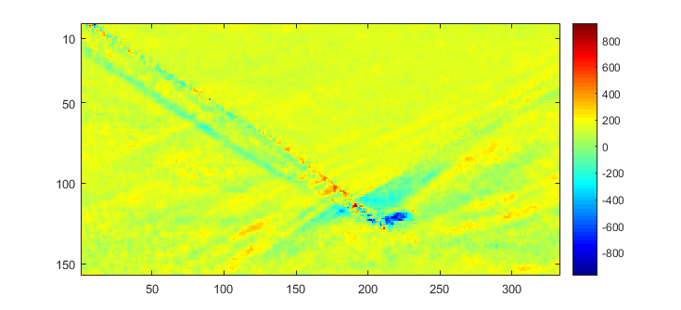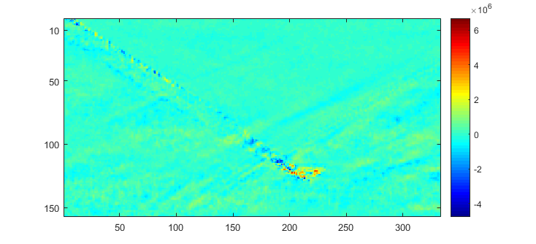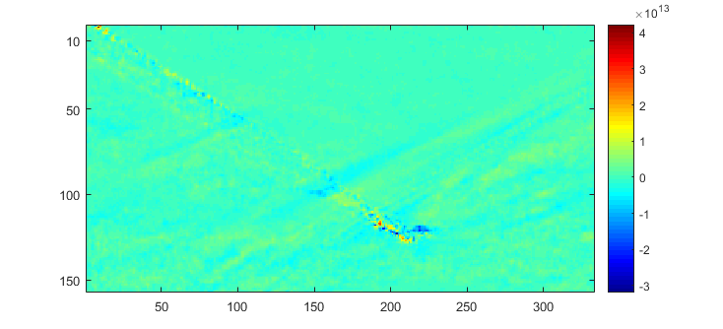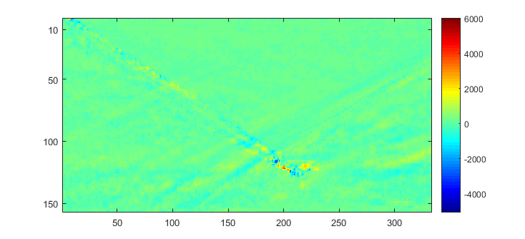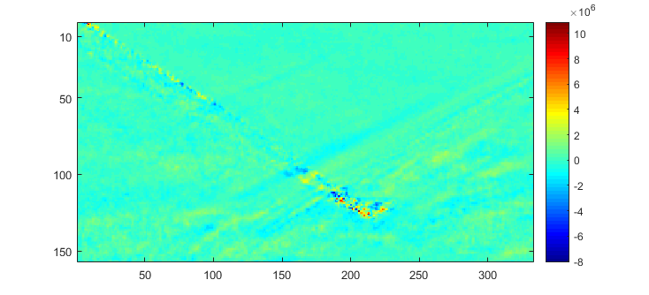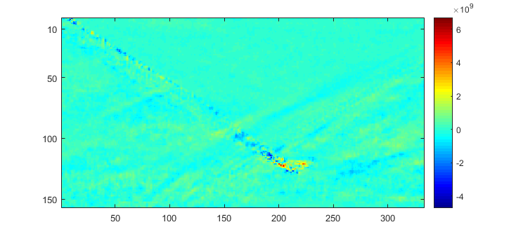

459 Hz

708 Hz

935 Hz

2350 Hz

6265 Hz

6501 Hz

9814 Hz

14243 Hz

**Figure 14. Reconstructed flow structures at different frequencies**

**Conclusions**

RSD together with image processing, ensemble averaging, snapshot POD and DMD techniques have been used to study the flow structure of the shockwave boundary layer interaction of an oblique shock originating from a wedge of 12° inclination for 5000 Hz and 30,000 Hz cases. The ensemble averaging results shows the different regions of the flow field including the incident, reflected, transmitted and separation shock waves, the separation bubble, the expansion zone and the compression waves downstream of the separation bubble. The RMS deflections calculated indicate that regions of increased fluctuations are located along the separation and reflected shock waves, at the edges of the compression zone and the separation bubble and the foot of the expansion zone. POD results gave distinct features around the separation, reflected shocks, over the separation bubble, and at the edges of the compression zone. The important observation was that the energy decreased at a faster pace with respect to increase in the mode number. Hence only the first nine modes were chosen to study the coherent flow structures. POD displayed coherent structures present in the flow but the energy ranking of the modes could not give the dynamic behavior of the system. DMD analysis not only helped in identifying the dynamic modes and corresponding flow structures but also was helpful in differentiating the results obtained using the snapshot POD. DMD plots also showed higher fluctuations at low to mid-level frequencies. However as the frequencies increased the flow structures started to saturate. DMD modes gave detailed information regarding the coherent flow structures present at certain frequencies. The dominant low frequency regions are concentrated surrounding the separation and reflected shocks and over the first half of the separation bubble with frequencies lower than 1000 Hz. However, the flow structures appeared to be saturated once the frequency increased from mid-level to higher frequencies. Parts of compression region just below the reflected shock behaved similar to the separated shock region upstream of the separation bubble. Flow downstream of the expansion fan closer to the reattachment compression region also displayed relatively low frequency motions.

# References

Dolling, D.S.,” Fifty Years of Shock-Wave/Boundary-Layer Interaction Research: What Next?” *AIAA Journal*, Vol. 39, No. 8, August, 2001.

Clemens T. Noel and Narayanaswamy Venkataswaran, “Shock/Turbulent Boundary Layer Interactions: Review of Recent Work on Sources of Unsteadiness” 39th AIAA Fluid Dynamics Conference, San Antonio, Texas, 22-25 June 2009.

Dussauge, J. P., Dupont, P., and Debieve, J. F., “Unsteadiness in shock wave boundary layer interactions with

separation.” *Aerospace Science and Technology*, Vol. 10, pp. 85-91. 2006.

Piponniau. S, Dussauge. J. P, Debieve. J. F, Dupont. P, “A simple model for low-frequency unsteadiness in shock-induced

separation”, *Journal of Fluid Mechanics*, 629 pp 87-108, 25 June 2009.

Kleine H, Groenig H,” Color schlieren methods in shock wave research “, *Shock Waves,* Vol. 1, p. 51-63, March 1991.

Sugiyama, Hiromu; Minato, Ryojiro; Mizobata, Kazuhide; Tojo, Akira; Muto, Yohei,” Study on shock wave and turbulent boundary layer interactions in a square duct at Mach 2 and 4” *Journal of Thermal Science*, Volume 15, Issue 1, pp.37-42

Burt W. Albers and Ajay K. Agrawal, “Schlieren Analysis of an Oscillating Gas-Jet Diffusion Flame”, Elsevier, Combustion and Flame, Volume 119, number 1, pp. 84-94, October 1999.

Kolhe, P.S., and Agrawal. A.K., 2009a, “Density Measurements in a Supersonic Microjet Using Miniature Rainbow Schlieren Deflectometry”, AIAA Journal, Vol. 47, No. 4.

Albers, B.W., and Agrawal, A.K.,1999, “Schlieren Analysis of an Oscillating Gas-Jet Diffusion Flame”, Elsevier, Combustion and Flame, Volume 119, Number 1, pp. 84-94.

Peter J. Schmid, “Dynamic mode decomposition of numerical and experimental data”, Journal of Fluid Mechanics, 2010, vol. 656, pp. 5–28.

P. J. Schmid · L. Li · M. P. Juniper · O. Pust, “Applications of the dynamic mode decomposition”, Theory of Computational Fluid Dynamics, April 2010.

Clarence W. Rowley, Igor Mezic, Shervin Bagheri, Philipp Schlatter and Dan S. Henningson, “Spectral analysis of nonlinear flows”, Journal of Fluid Mechanics September 2009.

Johnathan H. Tu, Clarence W. Rowley, Dirk M. Luchtenburg, Steven L. Brunton, J. Nathan Kutz, “On Dynamic Mode Decomposition: Theory and Analysis”

Muzio Grilli, “Analysis of the unsteady behavior in shockwave turbulent boundary layer interaction”, Dissertation, Technische Universitat Munchen, 2013

Joao Miguel Rosa Domingo, “Dynamic Mode Decomposition Method -application to the Earth's liquid core”, Dissertation, University of Coimbra, 2014

N.Vinha, F.Meseguer-Garrido, J.deVicente, E.Valero “A dynamic mode decomposition of the saturation process in the open cavity flow”, Aerospace Science and Technology 52 (2016) 198–206

Berkooz, G., Holmes, P., and Lumley, J.L., 1993, “The Proper Orthogonal Decomposition in the Analysis of Turbulent Flows”, Annual Review of Fluid Mechanics, Volume 25, pp.539-575.

Peter Schmid, Sesterhenn Joern, “Dynamic mode decomposition of numerical and experimental data”, American Physical Society, 61st Annual Meeting of the APS Division of the Fluid Dynamics, November 23-25, 2008.

Sirovich, L. “Turbulence and the dynamics of coherent structures.” Quart. Appl. Math., 45, 561–590, 1987

Ruhe, A.: Rational Krylov sequence methods for eigenvalue computations. Linear Algebra Appl. 58, 279–316 (1984)

Trefethen, L. N. & Bau, D. 1997 Numerical Linear Algebra. SIAM.

Greenbaum, A. 1997 Iterative Methods for Solving Linear Systems. SIAM.

1. Graduate student, Department of Aerospace Engineering and Mechanics

   2 Graduate student, Department of Aerospace Engineering and Mechanics

   3 Associate Professor, Department of Aerospace Engineering and Mechanics, AIAA Associate Fellow

   4 Assistant Professor, Mechanical Engineering Department